|  |
| --- |
|  |
| Mastering Magic |
| A Magic the Gathering Knowledge Base |

Michael Mammosser

Gregory Caldwell

Andrew DiBiasio

91.462 GUI Programing II

Professor Jesse Heines

February 3, 2015

Table of Contents

Project Goal 1

Feature Descriptions 1

Component Details 2

User Descriptions 5

Discussion of Issues 6

Acceptability Criteria 7

Minimum Functionality 7

Bonus/Future Functionality 7

Schedule 7

References 9

# Project Goal

Our goal is to provide information and statistics on Magic the Gathering to guide new players entry into one of the largest and most popular trading card games ever created. Magic the Gathering © 1995-2015 Wizards of the Coast LLC, also known as Magic, has one major flaw: its high barrier of entry. There are 14,000+ cards and hundreds if not thousands of different strategies used by experienced players. Our website will provide data on all the cards and common connections to other cards so that new users can more easily build their first deck and be successful.

# Feature Descriptions

The finished product will be an intuitive website that guides new Magic players through the process of selecting cards that will help them build a deck that works well with their playing style.. The site will have a basic starting guide that will explain the rules of the game and provide a description of each of the Magic card colors, as well as the most popular styles of decks with examples of tournament decks.

Not only will users learn how to play, they will also learn what to play. An all-inclusive card database, populated by http://mtgjson.com, will be used to display card information as well as an image of each card. Statistics on the card will be generated by queries to a second database of tournament decks populated by http://magic.wizards.com/en/articles/winning-decks.

To allow new players to better find cards that play well together, connections will be made between cards using both a database of common deck types populated from http://www.wizards.com/magic/displaythemedeck.asp and the database of tournament decks mentioned before.

The site will also link to other Magic resources to help new players with deck creation. One resource that will be linked is MTG Forums, such as http://www.mtgthesource.com/forums/forum.php, http://www.mtgsalvation.com/forums, and http://tappedout.net/mtg-forum/.

The last feature will provide a possible means of monetization in the future: each card will provide links to different locations to provide the possibility for players to purchase the card online.

# Component Details

The all-inclusive card database will be the backbone of the site. This database will be populated monthly via a background Python script set to run via Unix Contab. The script will download the latest mtgjson1 card library to a specified folder on the server. The script will then read the JSON file and convert it to a dictionary using Python. Next it will add a link to the card image from mtgimage2. Finally, the script will use a SQL merge statement to update existing cards and insert new ones into the card database.

The tournament and common deck type databases will be manually populated due to the data only existing on web pages. In the future, an HTML parser could be created via the BeautifulSoup3 Python library to automatically populate these databases.

The site will be styled using the AngularJS4 library, to add style and tabs to the website, as well as a custom theme created using assets from Magic’s fan site kit5.

The homepage (see Figure 1) will consist of the getting started guide, which explains the basics of Magic the Gathering. It will also link to useful resources and explain how to best use the site.

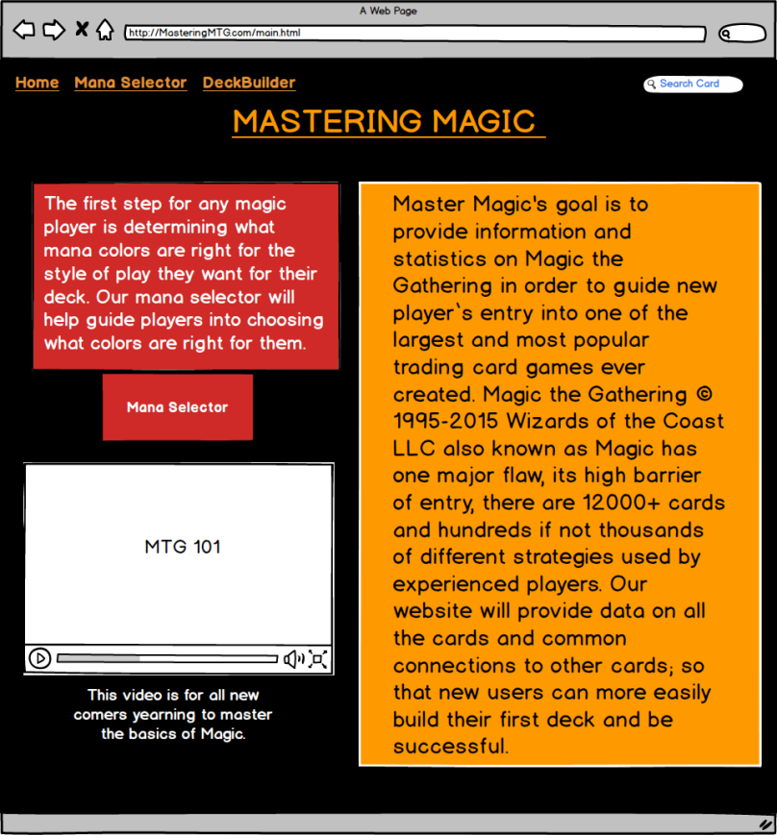

Figure 1. Mock Home Page

Our site will display card information on a page updated by PHP, using the reference parameter to designate which card is displayed. The card page will also implement an AngularJS search box for the auto fill feature.

A series of SQL join statements will be created to join the card database with the tournament/common deck databases. These statements will be used to generate useful statistics for each card to be displayed.

Each card’s page will include a picture of the card, text information from the card, and statistics related to its tournament use (see Figure 2). The card statistics will be displayed via the D3.js6 library which provides stunning graphical representations of the data. At the bottom of the page there will be links to common decks that the card is found in. To the right there will be a GUI to add the card to your deck. At the bottom of the page will also include links to purchase the card shown.



Figure 2. Mock Card Page

Our site will display deck information on a page updated by PHP while using the reference parameter to designate which deck is displayed. It will include card counts and links for each card in the deck as well as a link to Wizard’s theme decks page7,which describes how the deck is played.

The mana selector page (see Figure 3) will provide users with a description of all five choices of mana colors, as well as colorless mana. Using this information, users will be able to accurately select the mana colors that are fitting for their style of play.

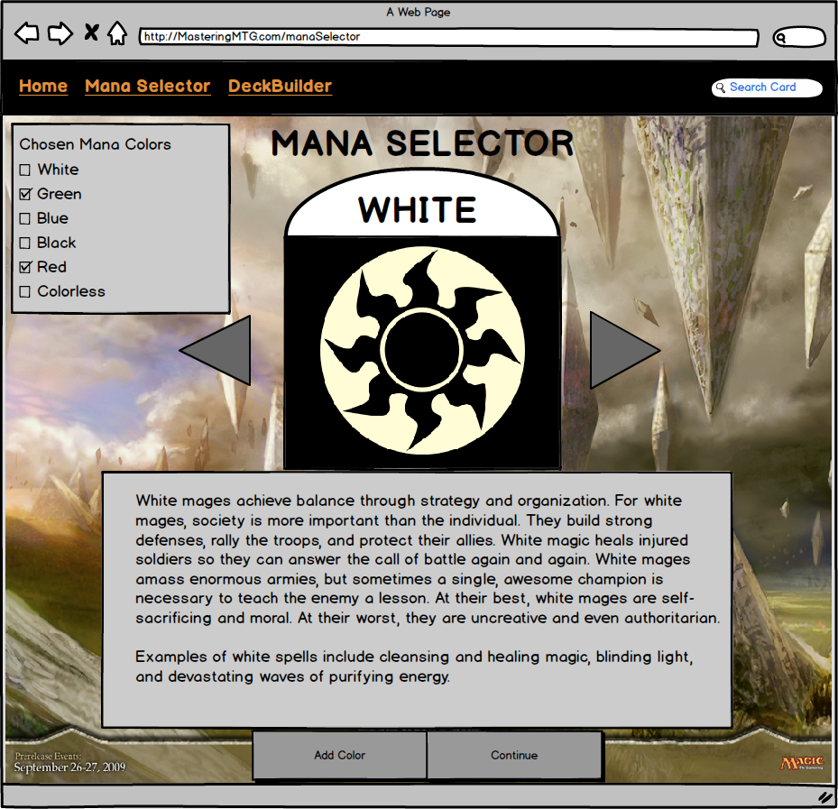

Figure 3. Mock Mana Selector

# User Descriptions

All users will need basic computer skills with some experience on the Internet and will need to speak and read English to properly use the website.

The primary audience of Mastering Magic will be new players interested in Magic the Gathering. Magic is rated 13+, therefore the website must be intuitive for all users who are at least thirteen years of age. The homepage will describe in detail how to play using images and small text blocks, keeping it as simple as possible.

The secondary audience will be seasoned players. The deck database and tournament statistics will draw in seasoned players who are looking to make a deck and need to find cards that work with their style of play.

# Discussion of Issues

* The project has a complicated backend which will take a lot of time to develop, but the GUI must take precedence due to its significance in the course. The project will need to be divvied up among the developers so that the backend and GUI features are created at the same time.
* The developers have limited PHP experience. Implementing multiple PHP pages will take time and will need to be developed early in project development so that the website can be styled properly.
* The development team is also tasked with creating an efficient card database to allow for quick server side queries. The database has to be quick to reduce page load times. Depending on WeBlab’s server performance, a third party server may have to be used. If load times are still slow, a limited number of users may be allowed to use the site.
* Time is the biggest issue with this project and a strict schedule has been set so that all of the goals will be reached by the final presentation.
* Managing this project between three people may end up being a problem. Having a GitHub repository with multiple people committing is a new approach for most of us, but may help with project management.
* (REWRITE THIS GREG). As a team, we collectively decided to focus on programming in AngularJS over JQuer or BootStrap. We came to the conclusion that AngularJS offers the most functionality to achieve all of Mastering Magic’s goals.

# Acceptability Criteria

## Minimum Functionality

* Detailed page for new users that explains how to play Magic the Gathering.
* Card page that displays the image and text information of any Magic card.
* Card page also links and displays associated decks.
* Card page also displays statistics of the card’s tournament play.
* Deck page that displays a link to each card and its count.

## Bonus/Future Functionality

* Card page uses D3.js to visually display statistical information.
* User login with user database.
  + Deck builder.
  + Comments section.
  + Forums.

# Schedule

A Google group has been created with a calendar of the project deadlines and internal deadlines set by the group. The group also includes a spreadsheet with each member’s responsibilities and their personal deadlines (See Figure 4). We will use GitHub for version control and will host the initial page on the WebLab system.

MM: Michael Mammosser, GC: Gregory Caldwell, AD: Andrew DiBiasio

|  |  |  |  |  |
| --- | --- | --- | --- | --- |
| Task Name | Duration | Start | Finish | Responsible |
| **Mastering Magic** | **64 days** | **Tue 2/3/15** | **Sun 5/3/15** |  |
| **Project Proposal** | **0 days** | **Tue 2/10/15** | **Tue 2/10/15** |  |
| Proposal Draft | 5 days | Tue 2/3/15 | Sun 2/8/15 | MM |
| Mock card.html | 1 day | Sun 2/8/15 | Sun 2/8/15 | GC |
| Mock manaSelector.html | 1 day | Sun 2/8/15 | Sun 2/8/15 | AD |
| Mock main.html | 1 day | Sun 2/8/15 | Sun 2/8/15 | AD |
| Proposal Editing | 3 days | Sun 2/8/15 | Tue 2/10/15 | MM,GC,AD |
| **Alpha Version** | **0 days** | **Fri 2/27/15** | **Fri 2/27/15** |  |
| Card Database | 3 days | Fri 2/6/15 | Tue 2/10/15 | MM |
| Deck Database | 8 days | Sun 2/8/15 | Tue 2/17/15 | GC,MM |
| PHP Database Connection | 6 days | Tue 2/10/15 | Tue 2/17/15 | MM,GC,AD |
| Alpha of mainStyle.css | 11 days | Tue 2/10/15 | Tue 2/24/15 | AD,MM,GC |
| Alpha of manaSelector.html | 11 days | Tue 2/10/15 | Tue 2/24/15 | AD |
| Alpha of main.html | 11 days | Tue 2/10/15 | Tue 2/24/15 | AD,MM |
| Alpha of decks.html | 11 days | Tue 2/10/15 | Tue 2/24/15 | AD,MM,GC |
| Alpha of cardSearch.html | 11 days | Tue 2/10/15 | Tue 2/24/15 | GC,AD |
| Alpha Testing | 4 days | Tue 2/24/15 | Fri 2/27/15 | MM,GC,AD |
| **Beta Version and Usability Test** | **0 days** | **Wed 4/15/15** | **Wed 4/15/15** |  |
| Card Statistics / Database Joins | 5 days | Fri 2/27/15 | Thu 3/5/15 | MM |
| Beta of mainStyle.css | 10 days | Fri 2/27/15 | Thu 3/12/15 | AD,MM,GC |
| Beta of manaSelector.html | 10 days | Fri 2/27/15 | Thu 3/12/15 | AD |
| Beta of main.html | 10 days | Fri 2/27/15 | Thu 3/12/15 | AD,MM,GC |
| Beta of decks.html | 10 days | Fri 2/27/15 | Thu 3/12/15 | AD,MM,GC |
| Beta of cardSearch.html | 10 days | Fri 2/27/15 | Thu 3/12/15 | GC,AD |
| D3.js Implementation | 11 days | Tue 3/10/15 | Tue 3/24/15 | MM,GC |
| Beta of deckBuilder.html | 18 days | Tue 3/24/15 | Thu 4/16/15 | MM,GC,AD |
| Beta Testing | 29 days | Thu 3/12/15 | Tue 4/21/15 | MM,GC,AD |
| **Class Presentations** | **0 days** | **Fri 4/24/15** | **Fri 4/24/15** |  |
| Prepare Presentation | 10 days | Tue 4/21/15 | Sun 5/3/15 | MM,GC,AD |
| **Final Submission Due** | **0 days** | **Sun 5/3/15** | **Sun 5/3/15** |  |
| **Poster Presentation** | **0 days** | **Sun 5/3/15** | **Sun 5/3/15** |  |
| Poster Creation | 10 days | Tue 4/21/15 | Sun 5/3/15 | MM,GC,AD |

Figure 4. Project Schedule

# References

1. "MTG JSON." Magic the Gathering Card Data in JSON Format. Web. 08 Feb. 2015. <http://mtgjson.com/>.
2. "MTG Image." Magic the Gathering Card Images. Web. 08 Feb. 2015. <http://mtgimage.com/>.
3. "BeautifulSoup 3.2.1 : Python Package Index." BeautifulSoup 3.2.1 : Python Package Index. Web. 08 Feb. 2015. <https://pypi.python.org/pypi/BeautifulSoup>.
4. "HTML Enhanced for Web Apps!" AngularJS. Web. 08 Feb. 2015. <https://angularjs.org/>.
5. "Daily MTG : Magic: The Gathering." Daily MTG : Magic: The Gathering. Web. 08 Feb. 2015. <http://archive.wizards.com/Magic/magazine/>.
6. "D3.js - Data-Driven Documents." D3.js - Data-Driven Documents. Web. 05 Feb. 2015. <http://d3js.org/>.
7. "MAGIC: THE GATHERING." MAGIC: THE GATHERING. Web. 08 Feb. 2015. <http://www.wizards.com/magic/displaythemedeck.asp>.